**Instructions for weekly programming assignments**

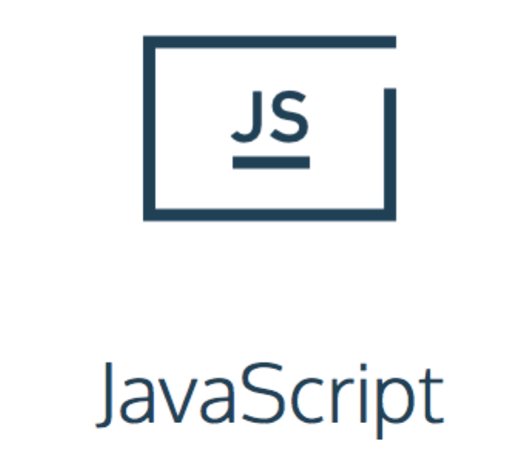

1. Go to [www.codecademy.com](http://www.codecademy.com) and create an account
2. Select “**JavaScript**” section from **Language Skills** in Catalog
3. Click “**START**” to start the course
4. Enjoy your learning

**What to do?**

You will have 8 UNITS in this course, where you will be required to complete at least 1 unit per week according to schedule below.

|  |  |  |  |  |  |
| --- | --- | --- | --- | --- | --- |
| **Week 1** | **Week 2** | **Week 3** | **Week 4** | **Week 5** | **Week 6** |
| Unit 1 | Unit 2 | Unit 3 | Unit 4 | Prepare for Midterm | Midterm Test |
|  |  |  |  |  |  |
| **Week 7** | **Week 8** | **Week 9** | **Week 10** | **Week 11** | **Week 12** |
| Unit 5 | Unit 6 | Unit 7 | Unit 8 | Prepare for Final | Final Test |

Each unit has several short lessons within it with very easy to follow instructions on what and how to do it. Just follow the instructions on the portal.

**How to submit?**



After completion of each unit you will have a Checkmark sign next to each lesson in the unit.

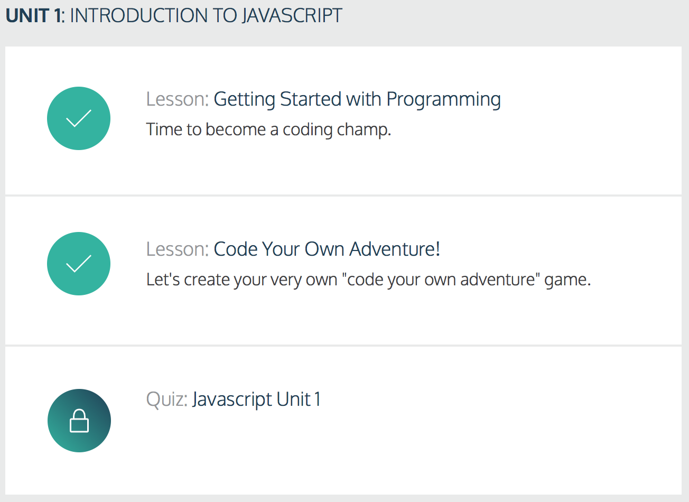To submit your homework all you have to do is take a screenshot of finished unit and attach it in the word document along with your other homework assignments as shown below:

Or just attach the screenshot image file along with your homework word document.

**What happens if I didn’t finish the unit on time?**

You can still submit it with your homework document, however it will be graded according to your completion %

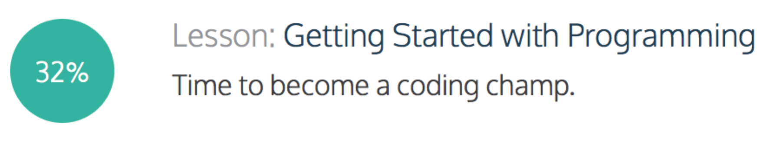

**Can I make up if “*my dog ate my homework*”?**

Yes, we will let you make up 1 time for missed programming homework. However, it is in your best interest not to skip, because each unit is related to previous one and if you miss one you might have a bit of a hard time understanding the next one.

**What if I already know at least 1 programming language, do I still need to complete this?**

No, if you already know at least 1 programming language you can just let us know and we will make a note that you don’t need to submit programming assignments.

However, to make sure you’re not just trying to avoid it, we will ask you a couple of simple programming questions that you will have to answer using whiteboard.

**How can I make a small screenshot without capturing everything that I have on my screen?**

If you are using **Mac**: <https://support.apple.com/en-us/HT201361>

Or “command” + “control” + “shift” + 4 to Copy

And then “command” + V into document (this way you don’t have to save it in a file)

If you are using **Windows**: <http://windows.microsoft.com/en-us/windows/use-snipping-tool-capture-screen-shots#1TC=windows-8>